Stubby

User’s Guide

February 2014

Contents
Contents 2
Virtual Interface Engine (VIE) 3
Designing Your Test 5
Determine the Transactions 5
Determine the Test Driver 5
Request and Response Pairs 5
Configuration Information 5
Capturing Traces 6
Preparing the Configuration File for Common Properties 7
Basic Structure 7
Core Properties 8
HEADER Tag Attributes: 8
Variables 9
Database Event Properties 14
Receiver Events 15
EventMessage 16
Baseline Messages 17
HTTPS Parameters 19
Plug-In User’s Guide 20
VIE File Structure 21
Top Level Directory 21
Command files 21
Documentation and configuration examples 21
Java Executable 21
Library Files 22
Log Files 22
Schema 22
Secure Socket Layer 22
Stub Sample Data 22
Service Wrapper files 22
Configuration Files 22

Virtual Interface Engine (VIE)

In performance testing the requirement for interfacing systems can sometimes cause delays in execution or inconsistent results due to Interfacing Systems:
- environment size, if not the same capacity as the System under test (SUT)
- environment availability, if it is being used by another testing project
- data alignment with SUT
- data size may not be production like in size or

VIE is a HTTPS stubbing program used to emulate downstream systems for performance testing.

Consider an environment that looks as follows…

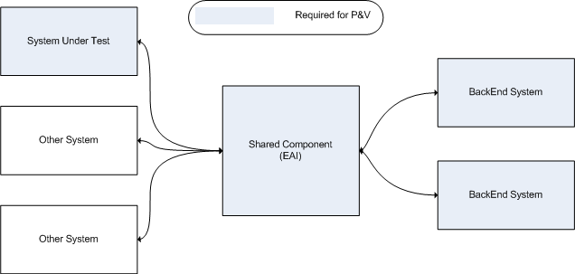

The use of a stubbing tool can simplify the environment requirements and approach to performance testing.

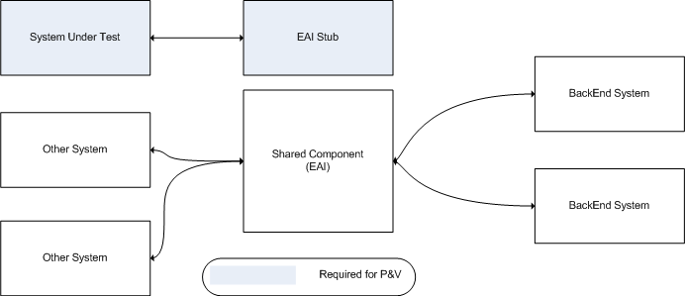

This user’s guide will cover each of these steps:
- Designing your test using stubby
- Capturing traces of requests and responses
- Preparing the common properties configuration file
- Preparing the configuration parameters for each protocol, or plug-in

Designing Your Test
The aim of the Stub is to allow you to isolate the system you want to test, so that it is the only system in play. This will prevent external systems from affecting your results. It also means you are not dependent on the presence of that system to complete your test. With this in mind, the design centres on illustrating the flows in and out of the system of concern to complete a transaction.

Determine the Transactions
Transactions can generally be identified from detailed test specifications or use case documents. They represent a flow through your system that serves a particular purpose. The first step in completing your design is to identify the list of transactions that you want to use in your test. With each transaction you have identified, you need to do the following. Some transactions will be simple in that involve only a test driver, others will be complex and will require not only a driver, but one or more request response pairs with external systems represented in order to complete the transaction.

Determine the Test Driver
The first important aspect of designing your test is to determine what drives the transaction. By this, we mean what triggers off the transaction in your source system. This can be an interface from an external system or driven from a user interface.

Request and Response Pairs
Once the driving source is identified, you trace the transaction through your system and seek to identify the series of request and response pairs involving your system and one or more external systems to complete the transaction.

Configuration Information
Once you have represented the flows for each transaction, you will need to capture the configuration information relevant to the protocol you are using. The required information for each protocol is addressed in the relevant sections of this document.

Capturing Traces
A crucial portion of the configuration is the template content. This requires either the capture of a trace from the external system you are emulating, or the development of a message from specifications using sample data relevant to your test. With driver configurations, you obviously need to capture the content of the output message. With stubs, you really only need to capture the output message you are required to generate, as long as you are aware of the key that will trigger that output. For design completeness however, it is recommended to capture the request or input message also if possible, as it allows for the identification of variables and extended keys.
Trace capture is generally the responsibility of technical staff of either the system you are testing and can be gained from members of the system you are testing. The worst case scenario is attempting to develop them from specification.

Preparing the Configuration File for Common Properties

Basic Structure
We are reliant on developing valid xml files in accordance with the stubby.xsd schema file. The easiest way to do this is to use an xml editor that will validate against this schema as you prepare the configuration file. This schema file contains the basic validations that need to be met in order to prepare a valid configuration for running the stub.
Aside from the header properties, the important components required are “Variables”, “Receiver Events” and “Baseline Messages”.
- “Variables” allow you to define ways to replace sections of the output message to satisfy your test case. They include such options as capturing a portion of the received message to place in the output message, simply string replacement, unique number replacement, pulling data in from a file, random number generation and others.
- “Receiver Events” define what you actually want to do when you receive a message that matches the key. The stub will then respond to incoming messages that match the key that you define.
- “Baseline Messages” contain the base content you want to use in your output messages. You refer to the baseline message with your receiver event and when you apply the variables you have defined to the baseline message, you get the complete output message required to send to the system you are testing.

Please note also the doc directory included with the software distribution contains samples for each supported protocol. Use these samples as a resource to prepare your valid files.

Core Properties
Core properties include the following attributes to describe the content of the configuration file:

<Core Author="Tim Lane" Name="ESG KISS V0.1" Description="ESG KISS Stub Port 9001" Date="07/02/2014">

Attribute | Required | Valid Values | Description
Name | Yes | String | A name to assist in the identification of the contents of the file with respect to logging
Description | Yes | String | A description of the contents of the file
Author | Yes | String | A tag to include details of who created the file
Date | Yes | String | A field to record the date the file was created

HEADER Tag Attributes:
Header attributes contain the logging information required.

<Header LogLevel=”INFO” LogFileName=”c:\temp\log4j.properties”/>

Attribute | Required | Valid Values | Description
LogLevel | Yes | ERROR  INFO  DEBUG  TRACE | Defines log level
LogFileName | Yes | Log4j properties file | The location of the log4j properties file.

MONITOR Tag Attributes:
Monitor attributes contain the Stub monitoring information required.

<StubMonitor MonitorHost="10.108.55.156" MonitorPort="9002" MonitorRefresh="10"/>

Attribute | Required | Valid Values | Description
MonitorHost | No | String | IP address of the server
MonitorPort | No | Integer | Port of the monitor server
MonitorRefresh | No | Integer  (default 10) | Number of seconds to wait before monitor refreshes.

Variables
There is some complexity in preparing the variable tag to contain a valid combination of attributes. The required attributes for a variable are defined by its type. To represent this, the following table contains all attributes and what they mean. Subsequent tables will list the valid combinations

Attribute | Required | Valid Values | Description
Name | Yes | String
Type | Yes | Number  String  Delimited  Positional  TimeStamp  RandomLong  RandomDouble  Guid  SessionId  ThreadCount  ContentLength  FileRead  FileLookup | Describes the type of variable you wish to use. For a detailed description of what each type means and the relevant parameters for that type, please see below.  Note:  Delimited and Positional are only relevant for INPUT type actions as they extract variable values from the input message.

Delimited

Captures information from the input stream based on defined tags.

<Variable Name="AccountNumber" Type="Delimited" RightOf="AccountNumberd&gt;" LeftOf="&lt;"/>

Attribute | Required | Valid Values | Description
LeftOf | Yes | String | Identifies the string sequence to indicate when the variable to extract ends in the input message. Used with Delimited type variables.
RightOf | Yes | String | Identifies the string sequence to indicate when the variable to extract begins in the input message. Used with Delimited type variables.  For MultiDelimited variables only a RightOf is required.
DefaultValue | No | String | If a matching variable does not find a value then the variable is set to the DefaultValue.

Positional

Captures information from the input stream based on position and length.

<Variable Name="AccountNumber" Type="Positional" StartPosition ="10" Length="16"/>

Attribute | Required | Valid Values | Description
StartPosition | Yes | Integer | The position in the input message that the variable value we wish to extract begins.
Length | Yes | Integer | Identifies the number of characters to extract from the input message from the start position identified with the StartPosition parameter.
DefaultValue | No | String | If a matching variable does not find a value then the variable is set to the DefaultValue.

TimeStamp

Generates the current or future/past timestamp.

Current Timestamp – Sample: 08:34:22
<Variable Name="TIMESTAMP" Type="Timestamp" Format="HH:mm:ss"/>

Current Timestamp plus one hour – Sample: 09:34:22
<Variable Name="TIMESTAMP" Type="Timestamp" OffSet=”3600” Format="HH:mm:ss"/>

Attribute | Required | Valid Values | Description
Format | No | String | Printf type string that specifies the format to represent a timestamp:  e.g. HH:mm:ss
OffSet | No | String | Number of seconds the timestamp should add/delete to current time. Is in number of seconds

RandomLong

Generates a random number between a defined range.

Random Long – between 1 and 99999999, Hex format – sample: 05222e32
<Variable Name="randToken1" Type="RandomLong" RandMin="1" RandMax="99999999" Format="%08x" />

Attribute | Required | Valid Values | Description
RandMax | Yes | Integer | The maximum boundary for the random number generator.
RandMin | Yes | Integer | The minimum boundary for the random number generator.
Format | No | String | Printf type string that specifies the format to represent a number.  Defaults for %d

Guid

Generates a Globally Unique Identifier.
<Variable Name="GUIDToken" Type="Guid" />

Attribute | Required |  | Valid Values |  | Description

Guid

Generates a Globally Unique Identifier.
<Variable Name="GUIDToken" Type="Guid" />

Attribute | Required |  | Valid Values |  | Description

SessionId

Generates a variable length session identifier.
<Variable Name="SessionId" Type="SessionId" SessionLength="10"/>

Attribute | Required | Valid Values | Description
SessionLength | No | Integer | Note that sessions are generated as HEX pairs and the sessionlength will need to reflect this.  e.g. a Sessionlength of 10 will result in a 20 character string.  If not entered defaults to 10 (20 character string)

Number

Provides a number that updates between iterations

<Variable Name="PCounter" Type="Number" InitialValue=”1” Increment=”1” Filename="counter.txt"/>

Attribute | Required | Valid Values | Description
Filename | Yes | String | The name of the file that stores the number between iterations and test executions.
InitialValue | No | Integer | Identifies the initial value the counter will start at.  If not set defaults to 0  If Filename is set this overrides this setting.
Increment | No | Integer | The increment to update the counter with.  If not set defaults to 1.

String

Provides a static string.

<Variable Name="StringVariable" Type="String" Value="testing" />

Attribute | Required | Valid Values | Description
Value | Yes | String | The string to be displayed.

ContentLength

Calculates the HTTP length of the response message.

Note: MUST be present for HTTP configurations and MUST be the LAST variable defined in the xml file.

<Variable Name="ContentLengthVariable" Type="ContentLength" />

Attribute | Required |  | Valid Values |  | Description

FileRead

Retrieves the value from a datafile. Data is read in a sequential manner or random.

<Variable Name="FileLookupPhoneNumber" Type="FileRead"
FileName="phonenumber.txt AccessType=”RANDOM”/>

Attribute | Required |  | Valid Values |  | Description
FileName | Yes | String |  | The filename to read the data from
AccessType | No | NEXT (default)  RANDOM |  | Determines which order to select values from the file array.  NEXT rotates through the file array. This is the default value  RANDOM chooses a random entry from the file array.

FileLookup

Retrieves the value from a datafile based on a variable.

NOTE: File lookups variables must be executed AFTER the variable that is to be used as the lookup key (KeyValue) for KeyType of VARIABLE.
Note: File must be comma delimited and have two columns only. Column 1 is the key column, column to the data column.

<Variable Name="LookupFile" Type="FileLookup" KeyType="VARIABLE" KeyValue="StringVariable1" Filename="C:\dbox\Dropbox\java\stubby\data\datafile2.txt"/>

<Variable Name="LookupFile" Type="FileLookup" KeyType="TEXT" KeyValue="1234" Filename="C:\dbox\Dropbox\java\stubby\data\datafile2.txt"/>

Attribute | Required |  | Valid Values |  | Description
FileName | Yes | String |  | The filename to read the data from
KeyType | Yes | TEXT  VARIABLE |  | TEXT searches the file use the KeyValue as the string  VARIABLE search the file using the value of the variable set in KeyValue
KeyValue | Yes | String |  | For Text this si the value that will be searchd  For VARIABLE this is the name of the variable that contains the search data.

Receiver Events
Receiver Events are what we want to actually happen in the configuration.

Receive Event determined by regular expression

<ReceiverEvent Name="ManageBpayDelete" KeyType="REGEX" KeyValue="bpaybiller.*DELETE">

Receive Event determined by string

<ReceiverEvent Name="ManageBpayAdd" KeyType="STRING" KeyValue="ADD">

Attribute | Required | Valid Values | Description
Name | Yes | String | Identifier for the name of the event. Useful to map it back to the test case you are using this event to represent.
KeyType | Yes | REGEX  STRING | Specifies whether to use a straight string comparison or a regular expression to resolve the key
KeyValue | Yes | String | The value to use in combination with the KeyType to resolve the key.

EventMessage
Messages for the basis of how and what we wish the VIE Stub to send. They contain the wait time configuration and refer to actual baseline message responses.

<EventMessage BaselineMessage="ManageBpayDelete" WaitDistribution="UNIFORM" MinWait="0.32" MaxWait="0.42" />

Attribute | Required | Valid Values | Description
BaselineMessage | Yes | String | The template name that contains the body of the message we are sending. The template must exist (see below)
WaitDistribution | Yes | UNIFORM | Specifies the type of distribution to apply to a random number generator that will determine how long to wait before sending the message
MinWait | Yes | Integer | The minimum number of seconds to apply to the wait distribution
MaxWait | Yes | Integer | The maximum number of seconds to apply to the wait distribution
QueueName | No | String | For MQ only: Overrides the default outbound queue.

Baseline Messages
Templates contain the body of each message. Depending on the protocol, they may also contain some parameters that are required by that protocol. They are used in combination with the variables to construct the actual body of the response.
Response content can be loaded in the config file or via an external file store.

<BaselineMessage Name="ManageBpayDelete"><![CDATA[this is a test response message send at %TimeStamp%]]><BaselineMessage>

Attribute | Required | Valid Values | Description
Name | Yes | String | The identifier for reference from Messages
Data | No | CData String | The actual content to be used to send out as the body of the text. Some protocols require particular lines at the beginning of the text to represent particular parameters required with that protocol. Please see the particulars for the protocol you wish to use for details.  Note: The data section of a template needs to be wrapped in the CData tag to indicate that it is to be ignored from an xml perspective as follows: <!CDATA[xxxx]]>

HTTP Message Example

- HTTP messages must contain both header and body details.
- The content length may be variable so it has to be replaced with a variable named %contentLength%.
- To determine body length the blank line between the Header and the body must be present.
- %contentLength% will be replaced with the body length after all other variables have been processed.
- All other variables will be processed as normal.

<BaselineMessage Name="httpTest"><![CDATA[
HTTP/1.1 200 OK
Date: Tue, 03 Dec 2013 05:28:18 GMT
Server: IBM_HTTP_Server
Cache-Control: no-cache
Content-Length: %contentLength%
Set-Cookie: JSESSIONID=0000qs210vZws94PX_6weFJxK0Z:1816e8d6n; Path=/
Set-Cookie: PLAY_FLASH=""; Expires=Thu, 01 Dec 1994 16:00:00 GMT; Path=/kissapi/; Secure
Set-Cookie: PLAY_SESSION=0833de0d00a7fc301607d5a902db3a2672ddcb1e-___ID=ed6fa802-4b99-4540-bf7f-7aed14085b28; Path=/kissapi/; Secure
Set-Cookie: PLAY_ERRORS=""; Expires=Thu, 01 Dec 1994 16:00:00 GMT; Path=/kissapi/
Expires: Thu, 01 Dec 1994 16:00:00 GMT
Connection: close
Content-Type: application/json; charset=utf-8
Content-Language: en

{"status":{"code":"1","message":"Success"},"token":{"accountToken":"061ba3a559907e82c51e18e3741f34ae","receivedBalance":"0","status":"OPEN","createDate":"2013-12-03T05:28:17Z","createUser":"GARY MARTIN","own":true,"expiry":[{"identifier":"SCAN","value":"2013-12-05T05:28:17Z","expired":false},{"identifier":"SMS","value":"2013-12-05T05:28:17Z","expired":false},{"identifier":"NFC","value":"2013-12-05T05:28:17Z","expired":false},{"identifier":"EMAIL","value":"2013-12-05T05:28:17Z","expired":false},{"identifier":"FACEBOOK","value":"2013-12-05T05:28:17Z","expired":false}],"id":"1b949b9b-3e17-43e9-b31d-74f564403603","bsb":"085397","accountNickname":"Personal Account #7177","direction":"IN","amount":"0.01","description":"Lunch","category":"Food","transactions":[],"accountIdDisplay":"576439921"}}
]]></BaselineMessage>

HTTPS Parameters
In addition to the port parameter for the HTTPS Stub, the following parameters are relevant for an HTTPS Stub using SSL:

<HTTPServer Host="10.108.55.148" Port="10001" ThreadCount="1000"
SSLKeyStore="c:\temp\vie\ssl\Newkeystore.jks"
SSLKeyPswd="password"
SSLKeyStorePswd="password"
SSLCertStore="certStore"
SSLClientAuth="false"
/>

Attribute | Required | Valid Values | Description
Host | Yes | String | The IP address of the stub server
Port | Yes | Integer | The port number the stub is listening on
ThreadCount | Yes | Integer | The number of threads in the thread pool
SSLKeyStore | Yes | String | The location and filename of the keystore containing the certificate
SSLKeyPswd | Yes | String | The password for the key store
SSLKeyStorePswd | Yes | String | The Password for the key to be used
SSLCertStore | Yes | String | The name of the certificate store
SSLClientAuth | Yes | TRUE  FALSE (Default) | Defines whether client auth is required.

HTTP Parameters

<HTTPServer Host="10.108.55.148" Port="10001" ThreadCount="1000" MonitorPort=”9001”/>

Attribute | Required | Valid Values | Description
Host | Yes | String | The IP address of the stub server
Port | Yes | Integer | The port number the stub is listening on
ThreadCount | Yes | Integer | The number of threads in the thread pool

MQ Parameters

MQ Server connection.

<MQSeries QManager="CL_TEST" WaitTime="0" ThreadCount="1000" >
<Inbound QueueName="inbound.queue"/>
<Outbound QueueName="inbound.queue" Correlate="TRUE"/>
</MQSeries>

Attribute | Required | Valid Values | Description
QManager | Yes | String | The name of the queue manager to connect to.
WaitTime | Yes | Integer | The number of seconds for the stub to wait for a queue message.  “0” means no wait time.
ThreadCount | Yes | Integer | The number of threads in the thread pool

<Inbound>
Attribute | Required | Valid Values | Description
QueueName | Yes | String | The name of the queue the stub is to read messages
MsgType | No | String  (default  MQMT_DATAGRAM) | The MQ message type.  MQMT_DATAGRAM  MQMT_REPLY
Format | No | String  (default  MQFMT_STRING) | The format of the inbound message.
Encoder | No | String  (default  STRING) | The encoding of the inbound message  MSG_FORMAT_EBCDIC  MSG_FORMAT_HEX
CcsId | No | Integer | The encoding codepage for HEX encoding.

<Inbound>
Attribute | Required | Valid Values | Description
QueueName | Yes | String | The name of the queue the stub is to write messages
MsgType | No | String  (default  MQMT_DATAGRAM) | The MQ message type.  MQMT_DATAGRAM  MQMT_REPLY
Format | No | String  (default  MQFMT_STRING) | The format of the outbound message.
Encoder | No | String  (default  STRING) | The encoding of the outbound message  MSG_FORMAT_EBCDIC  MSG_FORMAT_HEX
CcsId | No | Integer | The encoding codepage for HEX encoding.
Correlate | No | TRUE  FALSE (Default) | If true sets correlation to:  corrId to corrId, msgId to msgId.  If false then  msgId to corr Id, msgId is None

Plug-In User’s Guide

Plug-in | Java Class | Purpose
HTTP/S | com.Stub.http.httpsStub | Stub
MQ | com.Stub.mq.mqStub

To use each plug-in, the following parameter is mandatory:
Parameter | Required | Description
Filename | Yes | Location and name of the configuration file.

Example: java com.httpStub.core.httpsStub c:\temp\vie\xml\vie_test.xml

Note: following classpath must be set
set CLASSPATH=%HOMELOC%\vie.jar
set CLASSPATH=%CLASSPATH%;%HOMELOC%\lib\lava3-printf.jar
set CLASSPATH=%CLASSPATH%;%HOMELOC%\lib\lava3-core.jar
set CLASSPATH=%CLASSPATH%;%HOMELOC%\lib\com.ibm.mq.axis2.jar
set CLASSPATH=%CLASSPATH%;%HOMELOC%\lib\com.ibm.mq.commonservices.jar
set CLASSPATH=%CLASSPATH%;%HOMELOC%\lib\com.ibm.mq.defaultconfig.jar
set CLASSPATH=%CLASSPATH%;%HOMELOC%\lib\com.ibm.mq.headers.jar
set CLASSPATH=%CLASSPATH%;%HOMELOC%\lib\com.ibm.mq.jar
set CLASSPATH=%CLASSPATH%;%HOMELOC%\lib\com.ibm.mq.jmqi.jar
set CLASSPATH=%CLASSPATH%;%HOMELOC%\lib\com.ibm.mq.jms.Nojndi.jar
set CLASSPATH=%CLASSPATH%;%HOMELOC%\lib\com.ibm.mq.pcf.jar
set CLASSPATH=%CLASSPATH%;%HOMELOC%\lib\com.ibm.mq.postcard.jar
set CLASSPATH=%CLASSPATH%;%HOMELOC%\lib\com.ibm.mq.soap.jar
set CLASSPATH=%CLASSPATH%;%HOMELOC%\lib\com.ibm.mq.tools.ras.jar
set CLASSPATH=%CLASSPATH%;%HOMELOC%\lib\com.ibm.mqbind.jar
set CLASSPATH=%CLASSPATH%;%HOMELOC%\lib\com.ibm.mqjms.jar
set CLASSPATH=%CLASSPATH%;%HOMELOC%\lib\commons-lang3-3.2.1.jar
set CLASSPATH=%CLASSPATH%;%HOMELOC%\lib\connector.jar
set CLASSPATH=%CLASSPATH%;%HOMELOC%\lib\jai_imageio-1.1.jar
set CLASSPATH=%CLASSPATH%;%HOMELOC%\lib\jai_imageio_windows-i586.jar
set CLASSPATH=%CLASSPATH%;%HOMELOC%\lib\java-rt-jar-stubs-1.5.0.jar
set CLASSPATH=%CLASSPATH%;%HOMELOC%\lib\jcommon-1.0.17.jar
set CLASSPATH=%CLASSPATH%;%HOMELOC%\lib\jfreechart-1.0.14.jar
set CLASSPATH=%CLASSPATH%;%HOMELOC%\lib\lava3-core.jar
set CLASSPATH=%CLASSPATH%;%HOMELOC%\lib\lava3-printf.jar
set CLASSPATH=%CLASSPATH%;%HOMELOC%\lib\log4j-1.2.17.jar

VIE File Structure

The file structure of VIE is very flexible however the following conventions make it easier to support, develop and extend the framework.
All locations can be changed by an experienced user, for e.g. generally the log files can be located on a separate drive to the VIE core files.

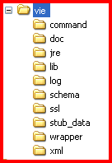

Top Level Directory

By default VIE exists in a directory call VIE. This directory can be on the root of a drive or in any subdirectory.

Command files

Files to execute VIE stubs are located in the command directory, typically either .bat or .cmd files.

Documentation and configuration examples

A copy of the VIE documentation and examples of configurations are located in the doc directory

Java Executable

For systems without java installed a copy of the java executable are located in the jre7 directory

Library Files

All VIE libraries files are located in the lib directory

Log Files

All VIE log files are located in the log directory

Schema

A copy of the VIE xsd schema is located in the schema directory

Secure Socket Layer

SSL certificates for HTTPS are located in the ssl directory

Stub Sample Data

Copies of data required for building stubs (request and response pairs) are located the stub_data directory

Service Wrapper files

Files to add and remove the VIE stub as a service are located in the wrapper directory.

Configuration Files

All VIE configuration files are located in the xml directory

MYSQL Interaction – Lookup.

VIE has the ability to lookup a database via a web interface typically a XAMPP server running Apache and mysql.

Overview

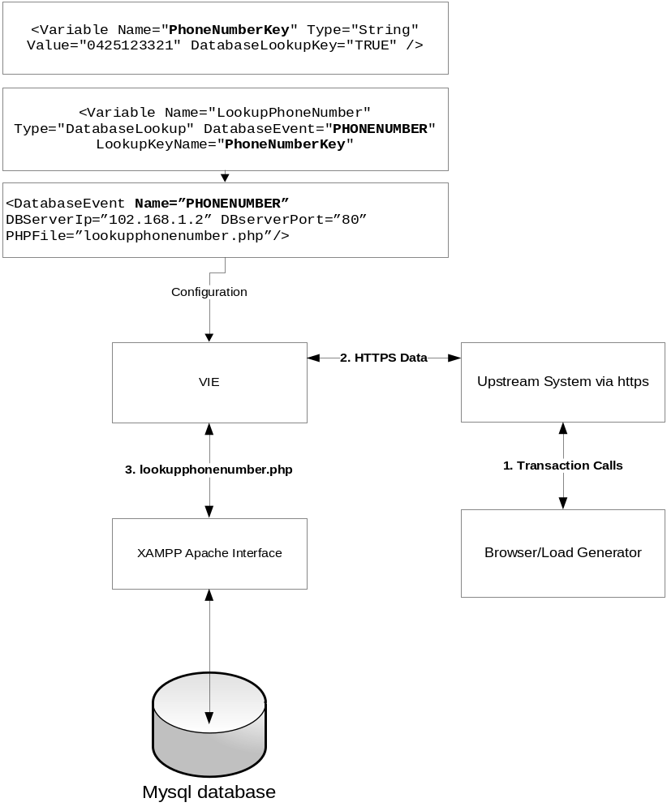

The lookup function is a web interface call from inside VIE.

Prerequisites.

- XML Config:

The following details must be setup in the VIE xml file.

Variable:

<Variable Name="PhoneNumberKey" Type="String" Value="0425123321" DatabaseLookupKey="TRUE" />

Note: Lookup Key variables must be located before lookup variables.

<Variable Name="LookupPhoneNumber" Type="DatabaseLookup" DatabaseEvent="PHONENUMBER" LookupKeyName="PhoneNumberKey" />

Note: Must have a matching DatabaseEvent entry.

DatabaseEvent:

<DatabaseEvent Name="PHONENUMBER" PHPFile="select.php" DBServerIP="localhost:80" />

Relationship Diagram

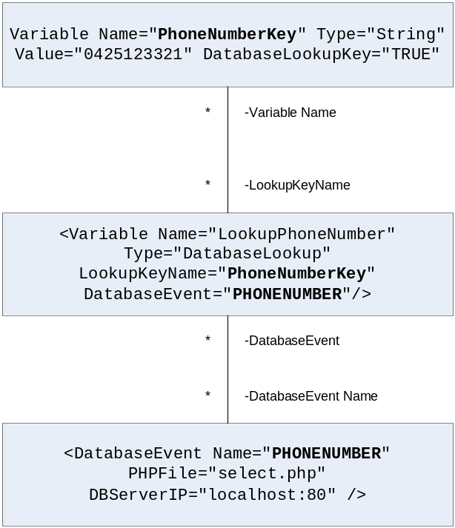

- XAMMP Server

Running on any server, must have apache, php and a mysql database configured.

- Database Setup:

Database setup to match that defined in insert.php (see below), no need for these details to be documented in the VIE XML apart for the fact that the TableField names should match the Variable names for clarity.

Database Elements | Details
DatabaseName | sms_code
TableName | Smscode
TableField | phoneNumber
TableField | smsCode

PhoneNumber | smsCode
0425123321 | 1234
0425321123 | 4567

- PHP Program file - lookup.php

A PHP file which is called from VIE for database lookups.

The GET values must match the Variable Name setup as the Key in the vie xml configuration file.

The response must be a single line.
If there are multiple data elements returned they must be broken up with a “:” character

<?php
// Script: lookup.php
// Owner: Tim Lane
// Date: December 2013
// Project: web site
// Details: script to lookup a phone number and return an sms code
// inputs: mobile phone number
// example: http://localhost:80/select.php?phoneNumber=0425123321
// outputs: one or more sms_code or failure message

$username="root";
$password="password";
$database="sms_code";

$field1_name=$_GET['PhoneNumberKey'];

mysql_connect("localhost",$username,$password);
@mysql_select_db($database) or die( "Unable to select database");

$query = "select smscode from `smscode` where `phoneNumber = '$field1_name";

$result=mysql_query($query);
while($row = mysql_fetch_assoc($result)){
foreach($row as $cname => $cvalue){
echo "$cvalue:";
}
}

if ($result!=1)
echo "Fail - select - Phone Number: $field1_name";
mysql_close();

MYSQL Interaction - Update

VIE has the ability to update a database via a web interface typically a XAMPP server running Apache and mysql.

Overview

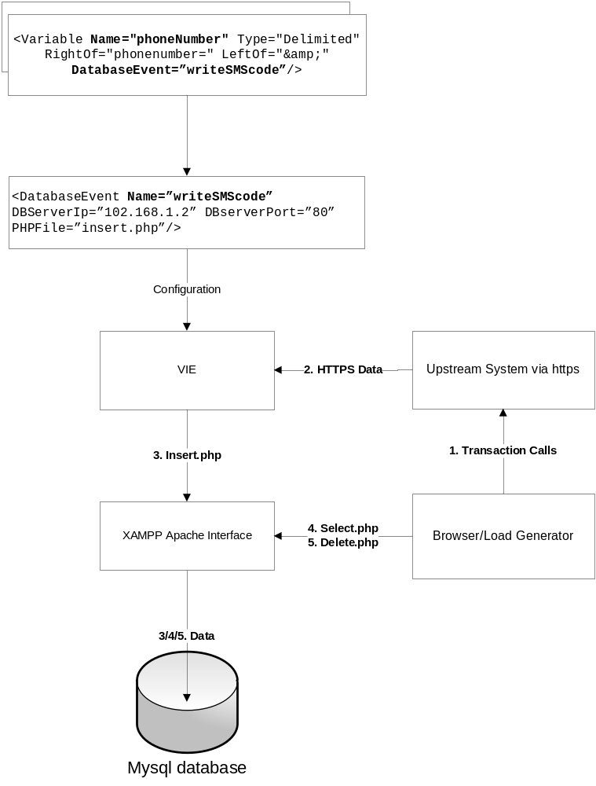

The Insert function is a web interface call from inside VIE.
Select and Delete functions can be called by any system with access to web interface.
Prerequisites.

- XML Config:

The following details must be setup in the VIE xml file.

Variable:

<Variable Name="phoneNumber" Type="Delimited" RightOf="phonenumber=" LeftOf="&amp;" DatabaseEvent=”writeSMScode”/>

<Variable Name="smsCode" Type="Delimited" RightOf="smscode=" LeftOf="&amp;" DatabaseEvent=”writeSMScode”/>

Note: Variable Name entries must have matching GET entries in the php file which handles database updates. (see sample insert.php file below)

Note: Variables must be used in a response message to work.

<ReceiverEvent Name="AccountDetails" KeyType="STRING" KeyValue="test_page">
<EventMessage BaselineMessage="AccountDetails" WaitDistribution="UNIFORM" MinWait="0.2" MaxWait="1.2"/>
</ReceiverEvent>
<BaselineMessage Name="AccountDetails">
<![CDATA[<soapenv:Envelope/">
<soapenv:Body>
<phonbeNumber>%phoneNumber%</phonbeNumber>
<smsCode>%smsCode%</smsCode>
</soapenv:Body>
</soapenv:Envelope>]]>
</BaselineMessage>

Note: Must have a matching DatabaseEvent entry.

DatabaseEvent:

<DatabaseEvent Name=”writeSMScode”
DBServerIp=”102.168.1.2”
DBserverPort=”80”
PHPFile=”insert.php”/>

- XAMMP Server

Running on any server, must have apache, php and a mysql database configured.

- Database Setup:

Database setup to match that defined in insert.php (see below), no need for these details to be documented in the VIE XML apart for the fact that the TableField names should match the Variable names for clarity.

Database Elements | Details
DatabaseName | sms_code
TableName | Smscode
TableField | phoneNumber
TableField | smsCode

PhoneNumber | smsCode
0425123321 | 1234
0425321123 | 4567

- PHP Program file - insert.php

A PHP file which is called from VIE for database updates.

The GET values must match the Variable Name setup in the vie xml configuration file.

<?php
// Script: insert.php
// Owner: Tim Lane
// Date: December 2013
// Project: web site
// Details: script to insert phone number and sms code into a database
// inputs: mobile phone number, sms code
// example: http://localhost:80/insert.php?phoneNumber=0425123321&smsCode=9999
// outputs: success or failure message

$username="root";
$password="password";
$database="sms_code";

$field1_name=$_GET['phoneNumber'];
$field2_name=$_GET['smsCode'];

mysql_connect("localhost",$username,$password);
@mysql_select_db($database) or die( "Unable to select database");

$query = "INSERT INTO `smscode`(`phoneNumber`, `smsCode`) VALUES ('$field1_name','$field2_name')";

$result=mysql_query($query);

if ($result==1)
echo "Success - Insert - Phone Number: $field1_name - SMS Code: $field2_name";
else
echo "Fail - Insert - Phone Number: $field1_name - SMS Code: $field2_name";
mysql_close();
?>

- PHP Program file - select.php

A PHP file which is called from an external program (Browser or Loadrunner) to get details for the database.

<?php
// Script: select.php
// Owner: Tim Lane
// Date: December 2013
// Project: web site
// Details: script to extract an sms code from the database
// inputs: mobile phone number
// example: http://localhost:80/select.php?phoneNumber=0425123321
// outputs: one or more sms codes
// example: smsCode:<sms code>:smsCode

$username="root";
$password="password";
$database="sms_code";

$field1_name=$_GET['phoneNumber'];

mysql_connect("localhost",$username,$password);
@mysql_select_db($database) or die( "Unable to select database");

$query = "SELECT smsCode FROM `smscode` WHERE phoneNumber ='$field1_name'";

$result=mysql_query($query);

while($row = mysql_fetch_assoc($result)){
foreach($row as $cname => $cvalue){
//print "$cname: $cvalue\n";
echo "$cname:$cvalue:$cname</BR>";
}
}

mysql_close();
?>

- PHP program file – delete.php

A PHP file which is called from an external program (Browser or Loadrunner) to delete details from the database when they are no longer required.

<?php
// Script: delete.php
// Owner: Tim Lane
// Date: December 2013
// Project: web site
// Details: script to extract an sms code from the database
// inputs: mobile phone number
// example: http://localhost:80/delete.php?phoneNumber=0425123321
// outputs: success or failure message

$username="root";
$password="password";
$database="smscode";

$field1_name=$_GET['phoneNumber'];

mysql_connect("localhost",$username,$password);
@mysql_select_db($database) or die( "Unable to select database");

$query = "delete from `smscode` where `phoneNumber` = '$field1_name'";

$result=mysql_query($query);

if ($result==1)
echo "Success - delete - Phone Number: $field1_name";
else
echo "Fail - delete - Phone Number: $field1_name";

mysql_close();
?>

